KOLKATA DISTRICT MEETING
Date: 04/09/2021
Time: 1 PM to 5 PM
Venue: Garima Greh, Mukundupur,Kolkata

Reporting By: Venkatesh Kodukula

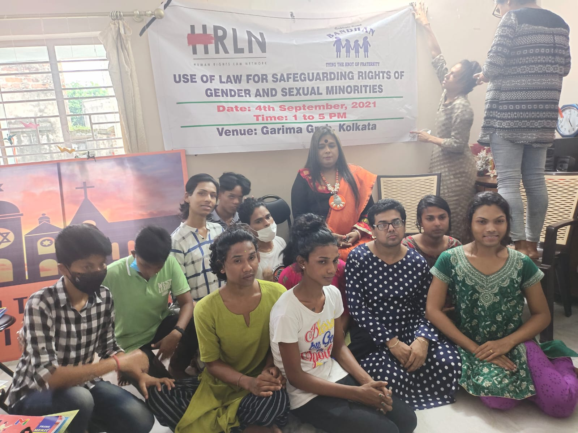

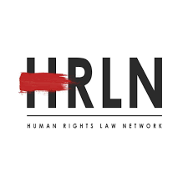
Use of Law for Safeguarding Rights of Gender and Sexual Minorities

SCHEDULE FOR MEETING

TIME | TOPIC | SPEAKER
1-1:15 | Welcome Note | Aparajita Bose, Asst. Director, HRLN WB
1:15-2:15 | Transgender Persons Act, 2019 and Rules 2020. | Mobina Ali, Advocate, HRLN Kolkata
2:15-3:15 | Gender Identity | Venkatesh Kodukula, Social Activist, HRLN Kolkata
3:15-4 | Trans Movement in India | Ranjita Sinha, Founder, ATHB
4-4:40 | NALSA Judgment and Case Discussion. | Joveria Sabbah, HRLN Kolkata
4:40-4:50 | Interactive Session & Action Plan | Advocates of HRLN
4:50-5 | Vote of Thanks

TABLE OF CONTENTS
1. | Introduction | 4
2. | Speakers | 5-6
3. | Interactive Session | 7
4. | Recommendation and Action Plan | 8
5. | Annexure A | 9-10
6. | Annexure B | 11-15

INTRODUCTION
The word “transgender” – or trans – is an umbrella term for people whose gender identity is different from the sex assigned to us at birth. Although the word “transgender” and our modern definition of it only came into use in the late 20th century, people who would fit under this definition have existed in every culture throughout recorded history. The trans community is incredibly diverse. Some trans people identify as trans men or trans women, while others may describe themselves as non-binary, gender queer, gender non-conforming, agender, bigender or other identities that reflect their personal experience. Some of us take hormones or have surgery as part of our transition, while others may change our pronouns or appearance.
While transgender people are increasingly visible in both popular culture and in daily life, we still face severe discrimination, stigma and systemic inequality. Some of the specific issues facing the trans community are:
- Lack of legal protection
- Poverty
- Stigma. Harassment and Discrimination
- Violence against Trans people
- Lack of Healthcare Coverage
- Identity documents
In 2014, the Indian Supreme Court NALSA v. India ruled that transgender people should be recognized as a third gender and enjoy all fundamental rights, while also being entitled to specific benefits in education and employment. Justice K.S. Radhakrishnan, writing for the bench, ordered that “Transgender persons’ right to decide their self-identified gender” should be recognized by state and federal authorities. The court made clear that “any insistence for [sex reassignment surgery] for declaring one’s gender is immoral and illegal.”
The Transgender Persons (Protection of Rights) Act, 2019 (‘Transgender Persons Act’) seeks to recognise the identity of transgender persons and prohibit discrimination in, inter alia, the fields of education, employment, healthcare, holding or disposing of property, holding public or private office and access to and use of public services and benefits.

SPEAKERS SESSION
Speaker 1: Aparajita Bose, Social Activist, HRLN Kolkata
The speaker introduced the whole team of HRLN and started a brief description about HRLN organization’s work for providing Legal Aid to the litigant, our organization do pro bono cases, how the organization supports Human Rights work which includes Disability Rights. They mentioned how they reach out to the deprived section of the society for giving justice to all.
Speaker 2: Venkatesh Kodukula, Social Activist, HRLN Kolkata
The speaker discussed on the Gender and Sexual Minorities and the ongoing problems faced by the community members especially during the pandemic. They had an interactive session with the participants. They discussed on the different types of gender identity and gender expression. The speaker further briefed on Section 377 of the Indian Penal Code and the various judgments related to the same. They mentioned how much of social taboos are associated still in the present date in regard to LGBTQIA+ community. They mentioned the problems faced by the community members especially during the pandemic and how many of them were residing in hostile environment. They focused on how till date the transgender individuals are not given equal opportunities though they have been given the third gender recognition back in 2014. They are been discriminated at different platforms from education to workspace. They speaker briefed on the different types of pronouns and how it is important to address someone.
Speaker 3: Mobina Ali, Advocate, HRLN Kolkata
The speaker discussed on the Transgender Protection Act 2019. She mentioned that according to Article 21 of the constitution, "No person shall be deprived of their life and personal liberty except according to a procedure established by law". She mentioned that according to the act no transgender person should be discriminated, denied or receive any unfair treatment in regard to education, employment, healthcare, etc. Transgender person has the right to access public spaces, right to reside/rent/occupy property. The speaker further highlighted on the welfare measures by the government which states that it will take measures to ensure the inclusion and participation of transgender individuals in the society and how government should take steps for the rescue and rehabilitation, vocational training and self employment for the well being of the transgender community.

Speaker 4: Ranjita Sinha, Founder, ATHB
The speaker discussed on the LGBTQIA+ rights in India. She mentioned that Indian LGBT citizens still face certain social and legal difficulties. The country has repealed its colonial-era laws that directly discriminated against homosexual and transgender identities and also explicitly interpreted Article 15 of the Constitution to prohibit discrimination on the basis of sexual orientation and gender identity. But many legal protections have not been provided for, including same-sex marriage. She further mentioned Transgender people in India are allowed to change their legal gender post-sex reassignment surgery under legislation passed in 2019, and have a constitutional right to register themselves under a third gender. Additionally, some states protect hijras, a traditional third gender population in South Asia through housing programmes, and offer welfare benefits, pension schemes, free operations in government hospitals as well as other programmes designed to assist them. There are approximately 480,000 transgender people in India.
Speaker 5: Joveria Sabbah, HRLN Kolkata
The speaker discussed on National Legal Services judgment which declared transgender people the 'third gender', affirmed that the fundamental rights granted under the Constitution of India will be equally applicable to them, and gave them the right to self-identification of their gender as male, female or third gender. She mentioned that the judgment has been distinguished as a major step towards gender equality in India. Moreover, the court also held that because transgender people were treated as socially and economically backward classes, they will be granted reservations in admissions to educational institutions and jobs. The Court upheld the right of all persons to self-identify their gender. The Court clarified that gender identity did not refer to biological characteristics but rather referred to it as “an innate perception of one’s gender”. Thus, it held that no third gender persons should be subjected to any medical examination or biological test which would invade their right to privacy. The speaker further mentioned that the Court held that public awareness programs were required to tackle stigma against the transgender community. It also directed the Central and State Governments to take several steps for the advancement of the transgender community, including:

- Making provisions for legal recognition of “third gender” in all documents
- Recognizing third gender persons as a “socially and educationally backward class of citizens” entitled to reservations in educational institutions and public employment.
- Taking steps to frame social welfare schemes for the community

INTERACTIVE SESSION
An interactive session was held with the people present in the meeting. In this interactive session, the participants raised various questions which were answered by the advocates and activists of HRLN.

RECOMENDATION & ACTION PLAN
An interactive session was held with the participants. In this interactive session, the participants raised various questions which were answered by the advocates and activists of HRLN. Many transgender individual came up seeking advice for the issue of Transgender identity cards. Advocates and Activists of HRLN are helping them legally for the same.

Annexure A
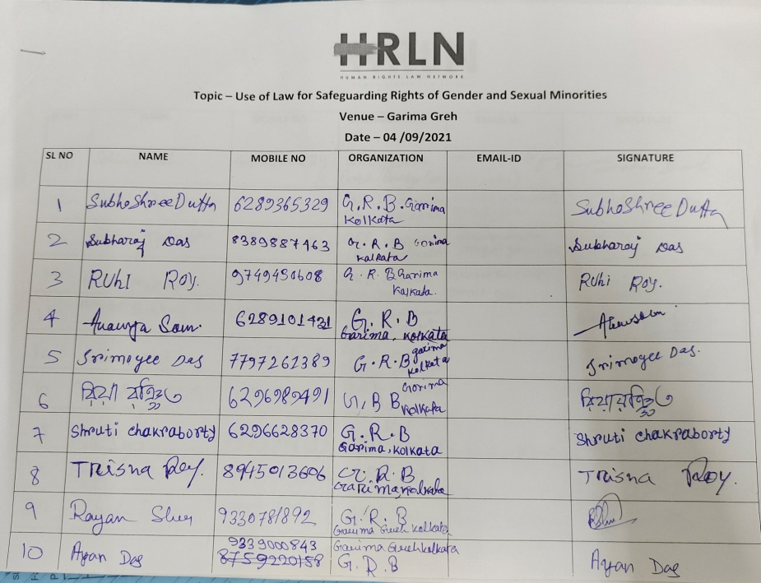

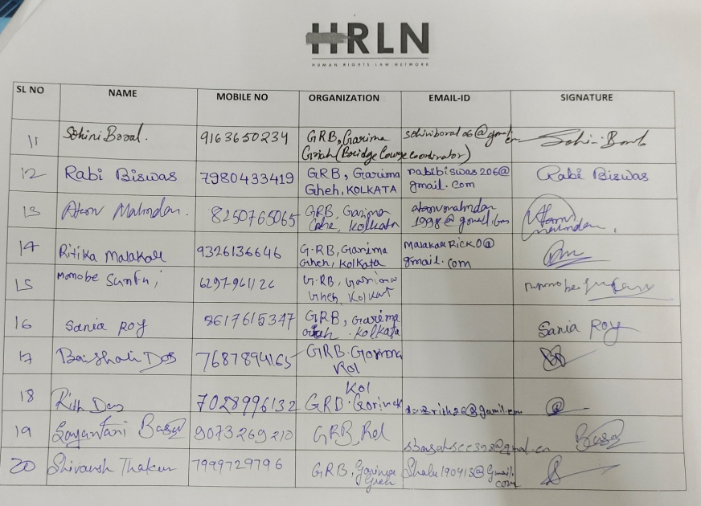
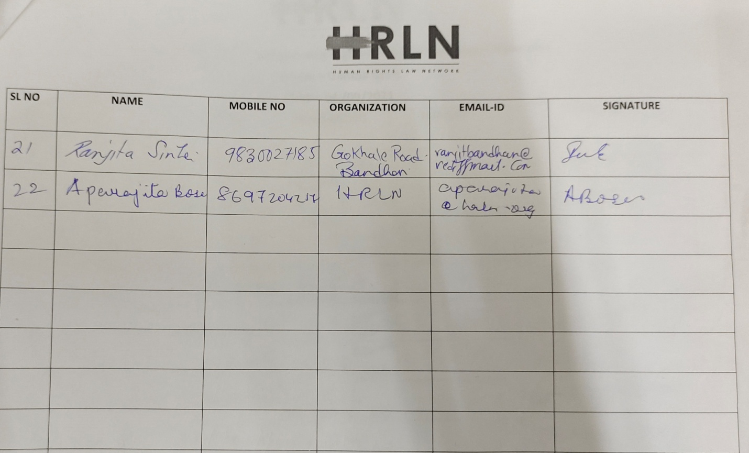

Annexure B
